**SQL PORTFOLIO PROJECT**

**TESTING TABLEAU/ POWER BI REPORTS IN SQL**

***Create Table:***

create table hrdata

(

emp_no int8 PRIMARY KEY,

gender varchar(50) NOT NULL,

marital_status varchar(50),

age_band varchar(50),

age int8,

department varchar(50),

education varchar(50),

education_field varchar(50),

job_role varchar(50),

business_travel varchar(50),

employee_count int8,

attrition varchar(50),

attrition_label varchar(50),

job_satisfaction int8,

active_employee int8

)

***Import Data in Table Using Query:***

COPY hrdata FROM 'C:\Users\тс\Desktop\Projects\Complete Project\SQL' DELIMITER ',' CSV HEADER;

***Employee Count:***

select sum(employee_count) as Employee_Count from hrdata;

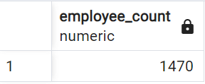

***Attrition Count:***

select count(attrition) from hrdata where attrition='Yes';

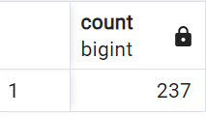

***Attrition Rate:***

select

round (((select count(attrition) from hrdata where attrition='Yes')/

sum(employee_count)) * 100,2)

from hrdata;

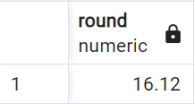

***Active Employees:***

select sum(employee_count) - (select count(attrition) from hrdata where attrition='Yes') from hrdata;

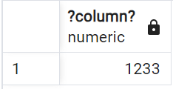

***Average Age:***

select round(avg(age),0) from hrdata;

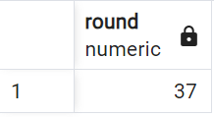

***Attrition by Gender:***

select gender, count(attrition) as attrition_count from hrdata

where attrition='Yes'

group by gender

order by count(attrition) desc;

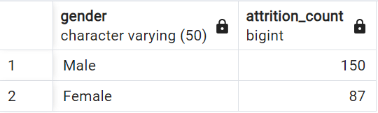

***Department Wise Attrition:***

select department, count(attrition), round((cast (count(attrition) as numeric) /

(select count(attrition) from hrdata where attrition= 'Yes')) * 100, 2) as pct from hrdata

where attrition='Yes'

group by department

order by count(attrition) desc;

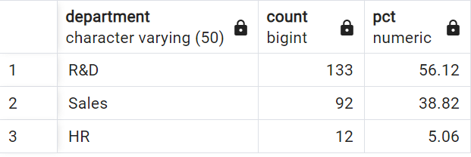

***No of Employees by Age Group:***

select age, sum(employee_count) as employee_count from hrdata

group by age

order by age;

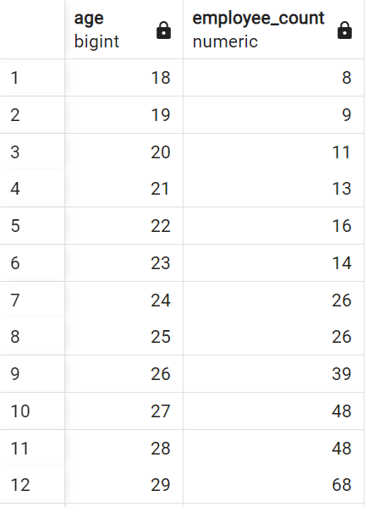

...

***Education Field Wise Attrition:***

select education_field, count(attrition) as attrition_count from hrdata

where attrition='Yes'

group by education_field

order by count(attrition) desc;

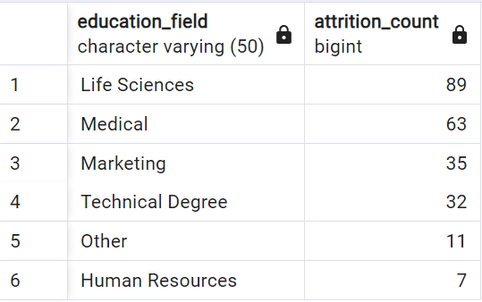

***Attrition Rate by Gender for Different Age Groups:***

select age_band, gender, count(attrition) as attrition,

round((cast(count(attrition) as numeric) / (select count(attrition) from hrdata where attrition = 'Yes')) * 100,2) as pct

from hrdata

where attrition = 'Yes'

group by age_band, gender

order by age_band, gender desc;

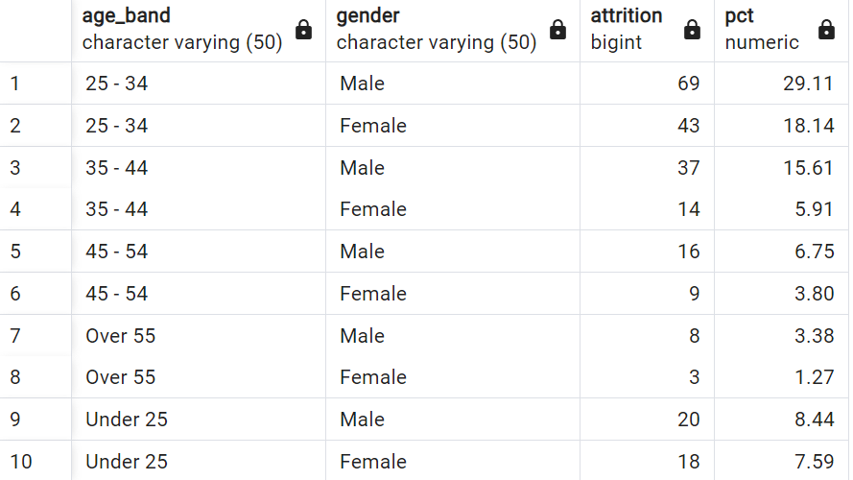

***Job Satisfaction Rating:***

- - Activating the cosstab() function

CREATE EXTENSION IF NOT EXISTS tablefunc;

- - Then

select *

from crosstab(

'select job_role, job_satisfaction, sum(employee_count)

from hrdata

group by job_role, job_satisfaction

order by job_role, job_satisfaction'

) as ct(job_role varchar(50), one numeric, two numeric, three numeric, four numeric)

order by job_role;

